Mother Shruti(Vedas):

Ekoham bahusyami (Lord Vishnu wanted to manifest Himself in different forms)

Lotus appeared from His naval and he created Lord Brahma and gave him a job to create a universe where a lot like Him can flourish.

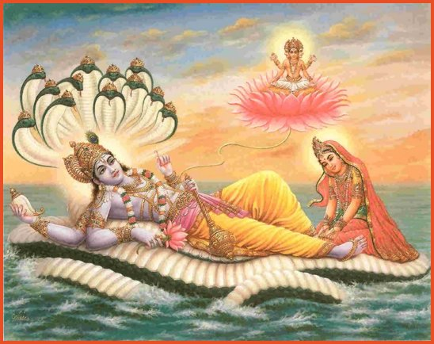

Lord Brahma created 5 essential elements (earth, sky, water, air, fire). The atoms of which combined with one another and formed physical bodies.

C:\Program Files\Microsoft Office\MEDIA\CAGCAT10\j0281904.wmf

[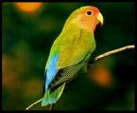](http://rds.yahoo.com/_ylt=A0WTefZXFfxLUA8AoaiJzbkF;_ylu=X3oDMTBpc2ozM2gzBHBvcwM0BHNlYwNzcgR2dGlkAw--/SIG=1k09snsqb/EXP=1274898135/**http:/images.search.yahoo.com/images/view?back=http://images.search.yahoo.com/search/images?p=birds&ei=UTF-8&fr=yfp-t-701&w=500&h=412&imgurl=media-content.flixya.com.s3.amazonaws.com/files/rafiq216962.jpg?AWSAccessKeyId=1TKE66PETJJHG8051M02&amp;Expires=2117774364&amp;Signature=tVEYYIf+SMOO5kHwGAxR3pUPXds=&rurl=http://www.flixya.com/photo/216962/Birds&size=129k&name=Birds&p=birds&oid=bd36545b5f0be496&fr2=&no=4&tt=19675124&sigr=1182fqvnl&sigi=159vmjimq&sigb=12a63f2vr)

C:\Program Files\Microsoft Office\MEDIA\CAGCAT10\j0216724.wmf

[](http://rds.yahoo.com/_ylt=A0WTefVFFvxLal0AJbGJzbkF;_ylu=X3oDMTBpcWpidGtpBHBvcwM4BHNlYwNzcgR2dGlkAw--/SIG=1i9bo8fpa/EXP=1274898373/**http:/images.search.yahoo.com/images/view?back=http://images.search.yahoo.com/search/images?p=insects&b=1&ni=18&ei=utf-8&xargs=0&pstart=1&fr=yfp-t-701&w=640&h=640&imgurl=pics4.picvi.com/media/pics/2008/07/02/Insects/09.jpg&rurl=http://www.picvi.com/2008/07/02/insects-2&size=70k&name=Insects&p=insects&oid=04e6c7a0585c1d30&fr2=&no=8&tt=4728830&b=1&ni=18&sigr=119k36a3h&sigi=11kdoospp&sigb=137evuo1g)

C:\Program Files\Microsoft Office\MEDIA\CAGCAT10\j0332364.wmf

Lord Brahma then made them alive by putting Life Force (Pran-Fraction of God) in each of them.

Lord Brahma created 24 syllable Mantra (the great Gayatri Mantra) to guide for how to live life; Our politics, economics, health, Dharma, desires etc. ||Om bhur bhuvah swah tat savitur varenyam bhargo devasya dheemahi dhiyo onah prachodayat ||

People heard the meaning of each syllable of this greatest mantra in divine voice (Shrvan – hearing). They explained it to others. Thus a lot of knowledge ccumulated.

Risi Krishnadwaipayan Vyasa – compiled all knowledge into four classes: Rigveda(Dharma), Samveda(Desires), Yajurveda(Politics), Atharvaveda(Economics) Thus Vedas are known as Shruties. They are the Brahmgyan, the Ultimate knowledge.